**Migrate EC2 instance from One Region to Another Region**

1. Create EC2 instance in Singapore Region

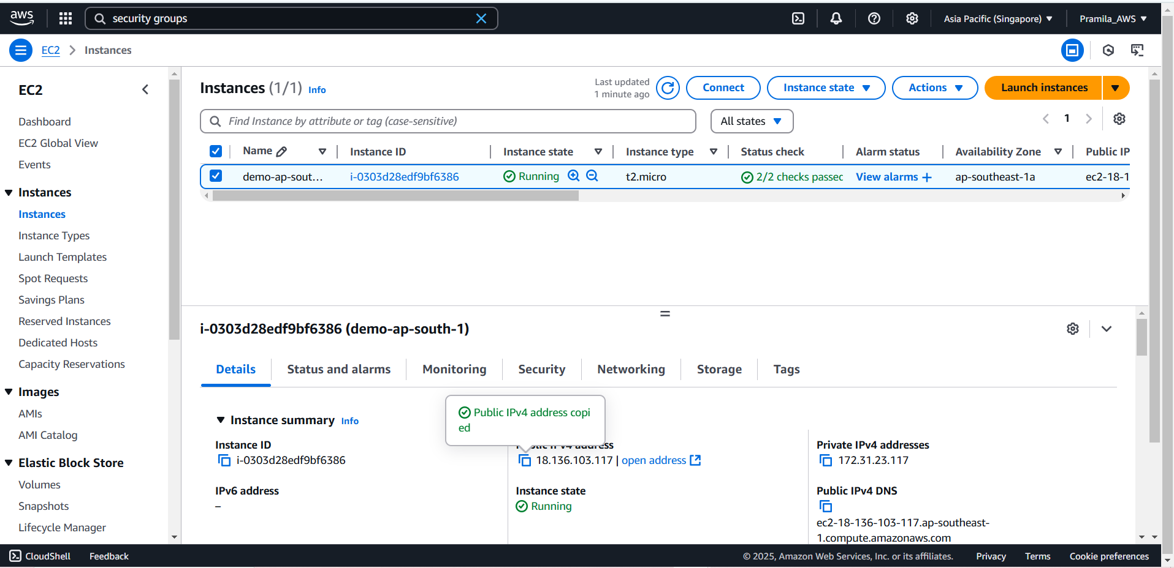

1. Install Git, Java, Apache Maven and Jenkins application

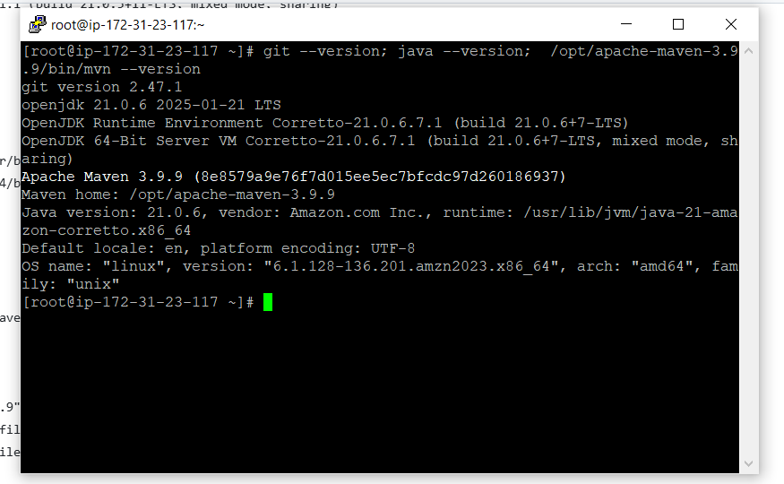

1. Create inbound rule for Jenkins application. Jenkins running on port 8080

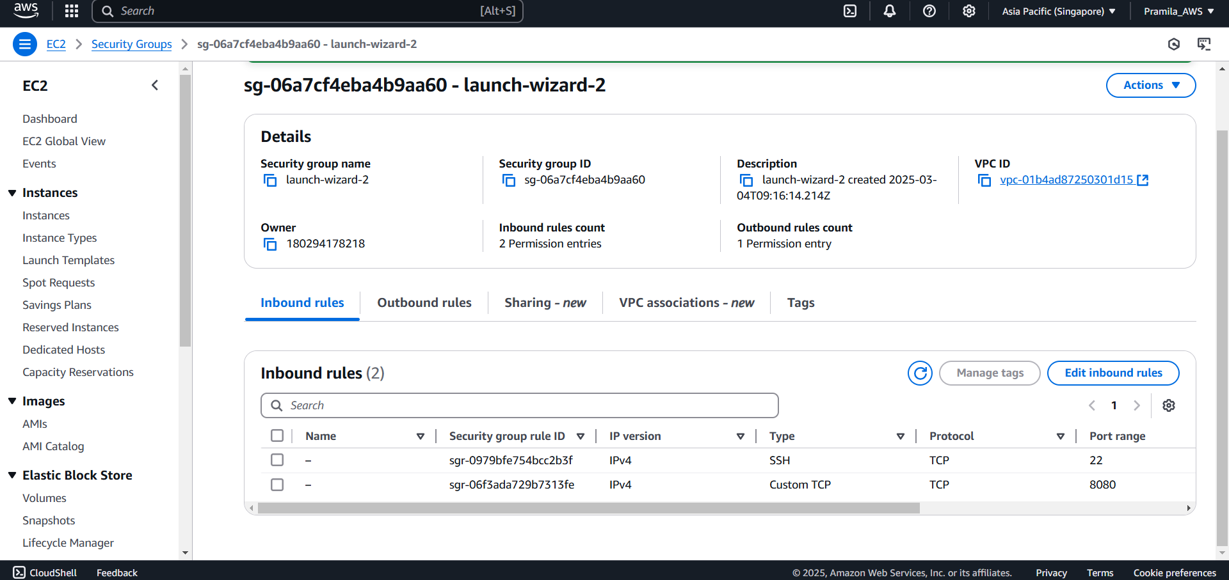

1. Now we can open Jenkins application using <http://publicip:8080>

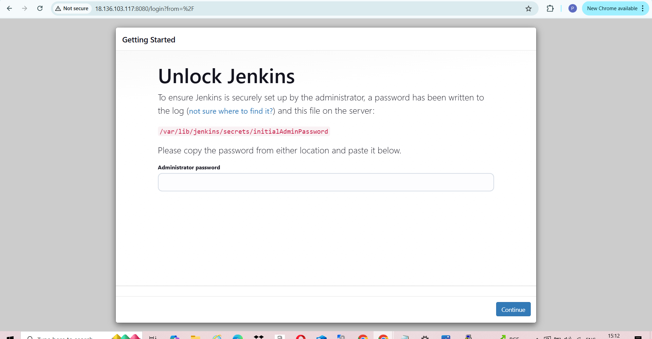

1. Enter password which is stored in cat /var/lib/jenkins/secrets/initialAdminPassword location

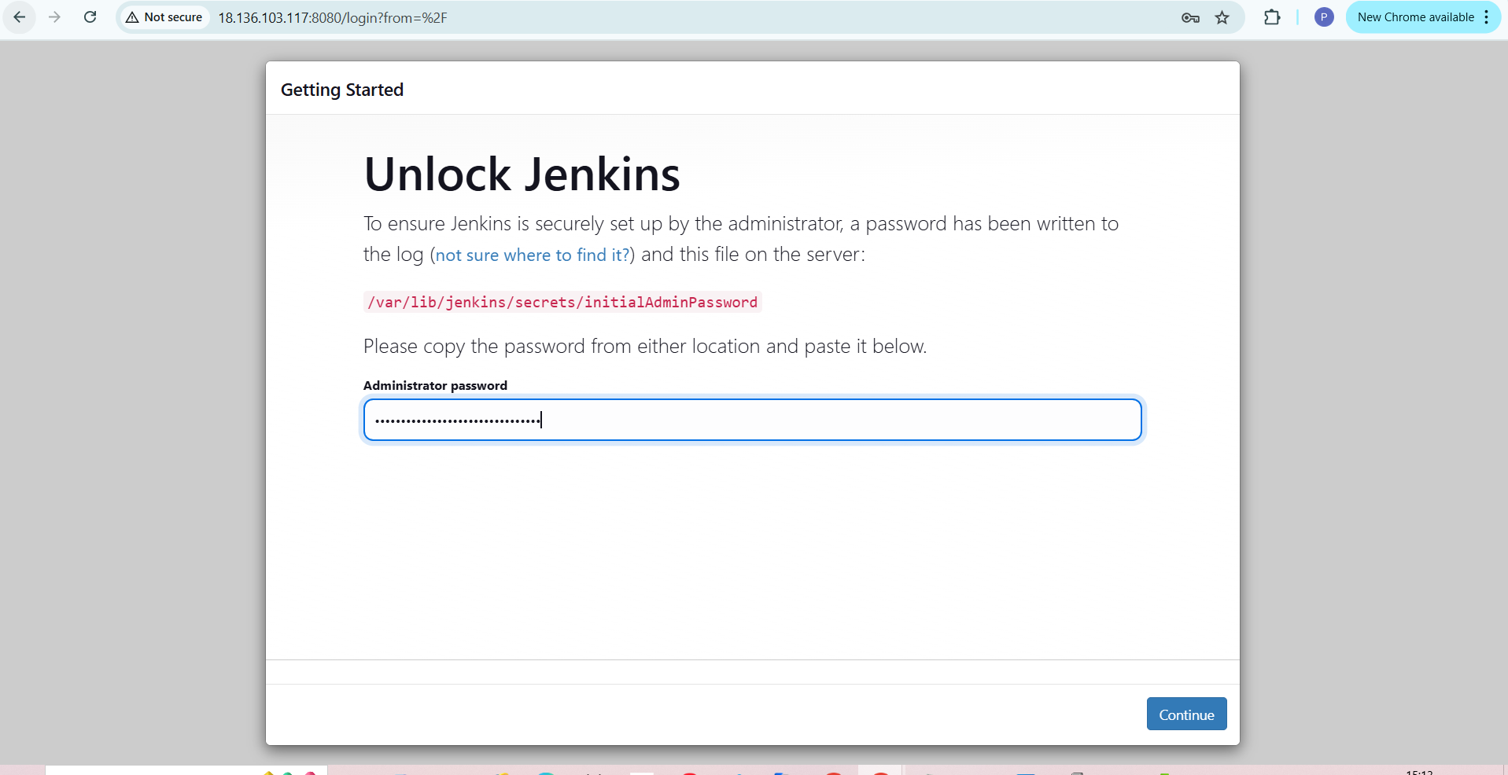

1. Now it is setting up the application

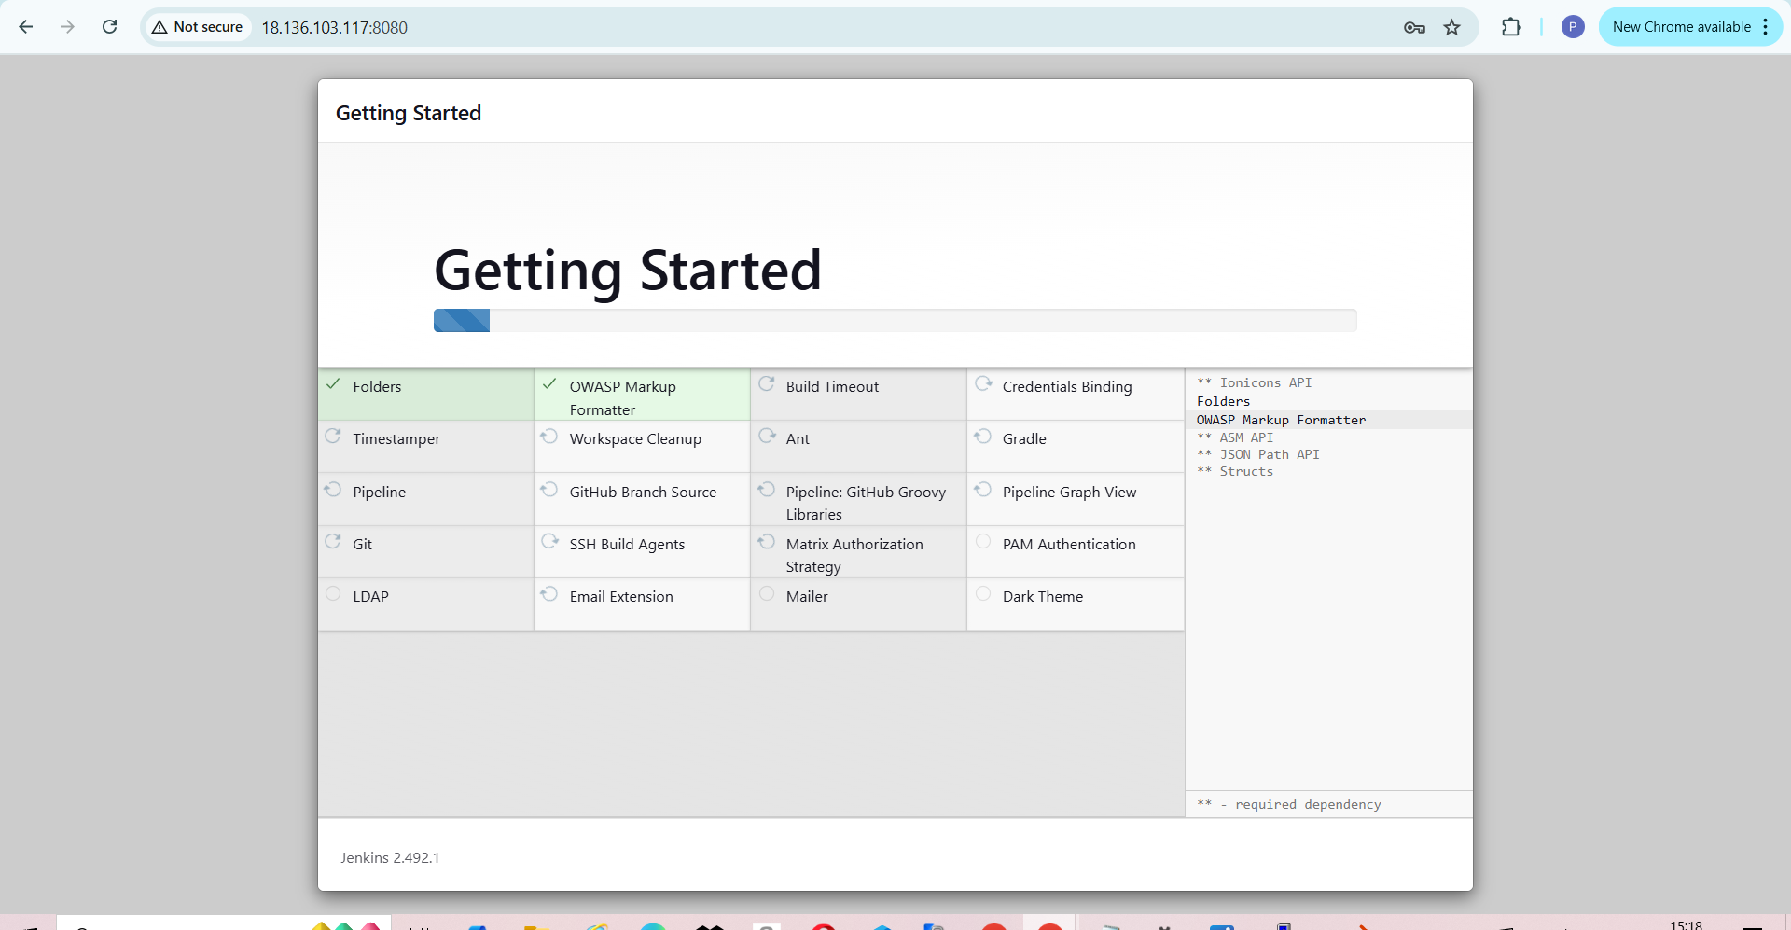

1. Do the configuration in Jenkins for disk space

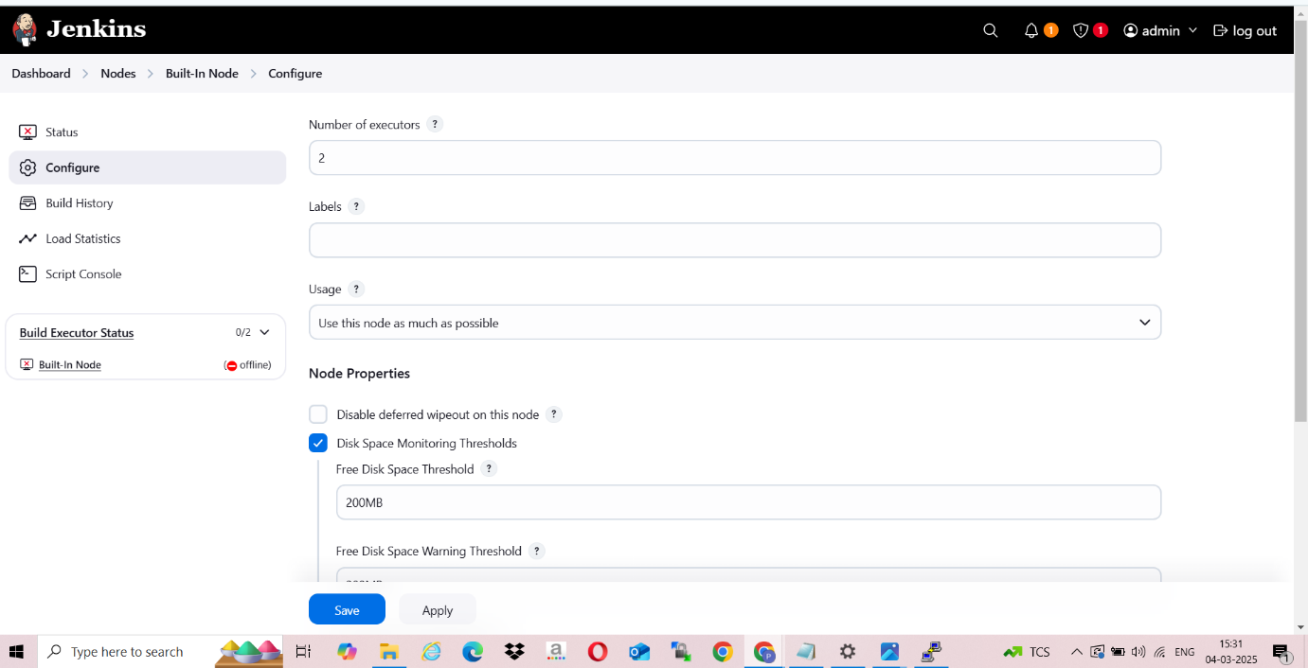

1. Console output for created new item to display date on console

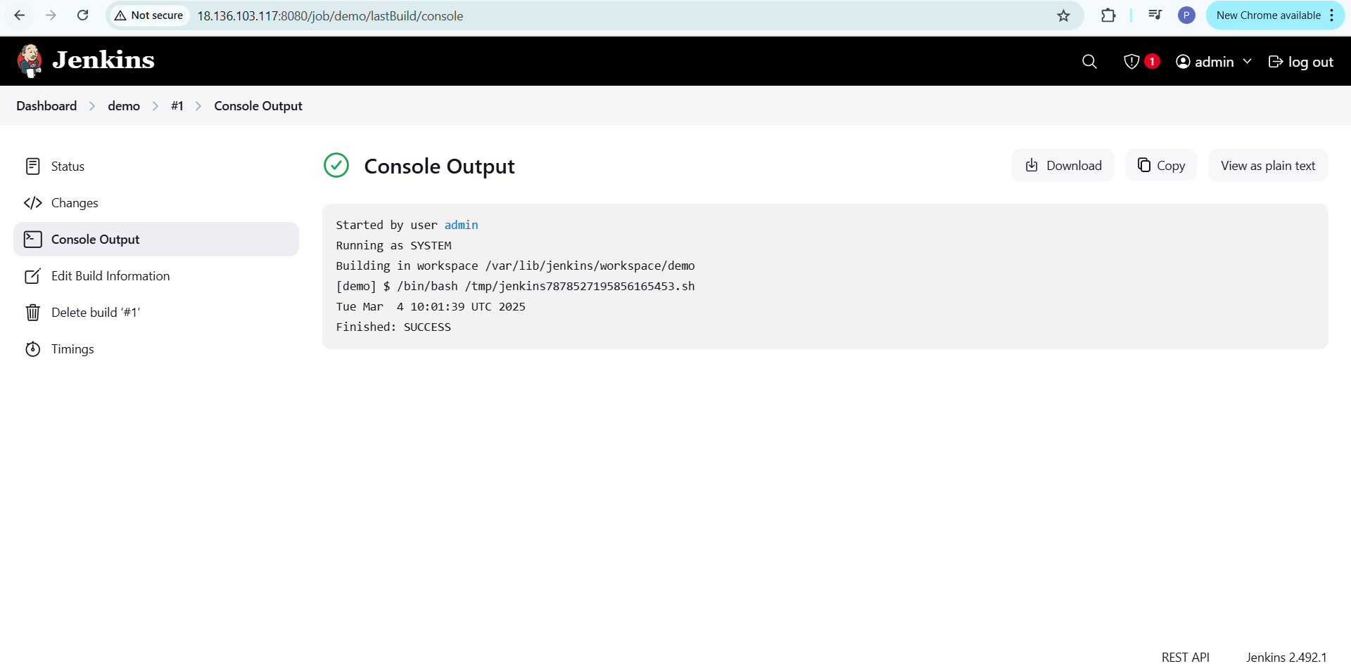

1. Now create snapshot from volume of ec2 instances which is having all application installed

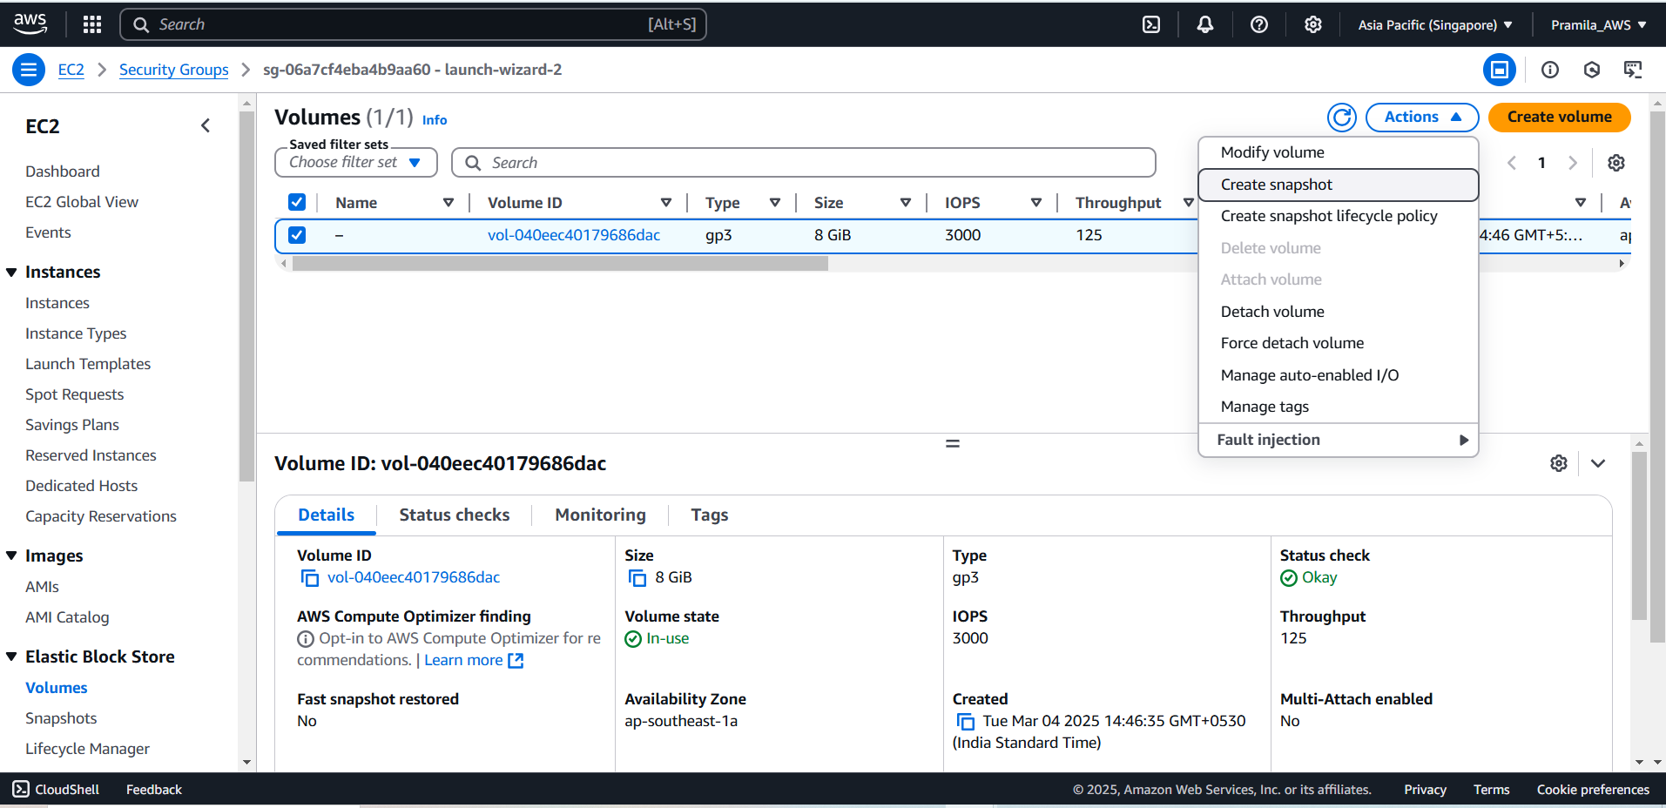

1. Created snapshot from volume

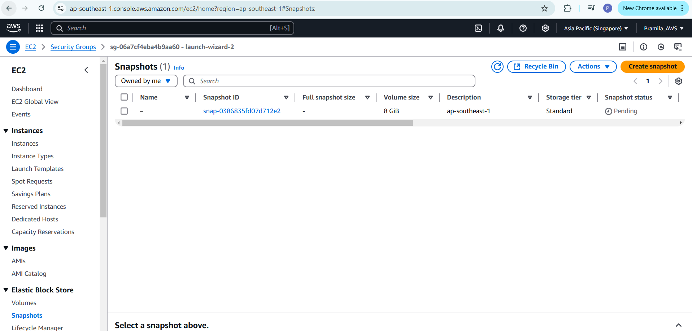

1. Copy snapshot from Singapore region to Mumbai region

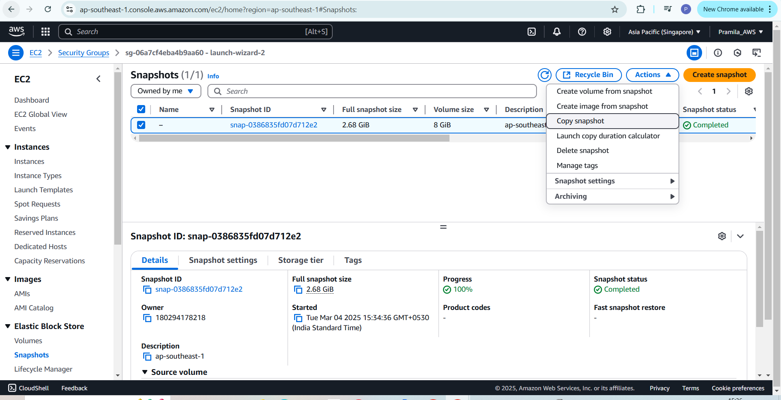

1. While copying snapshot add destination region as Mumbai (ap-south-1)

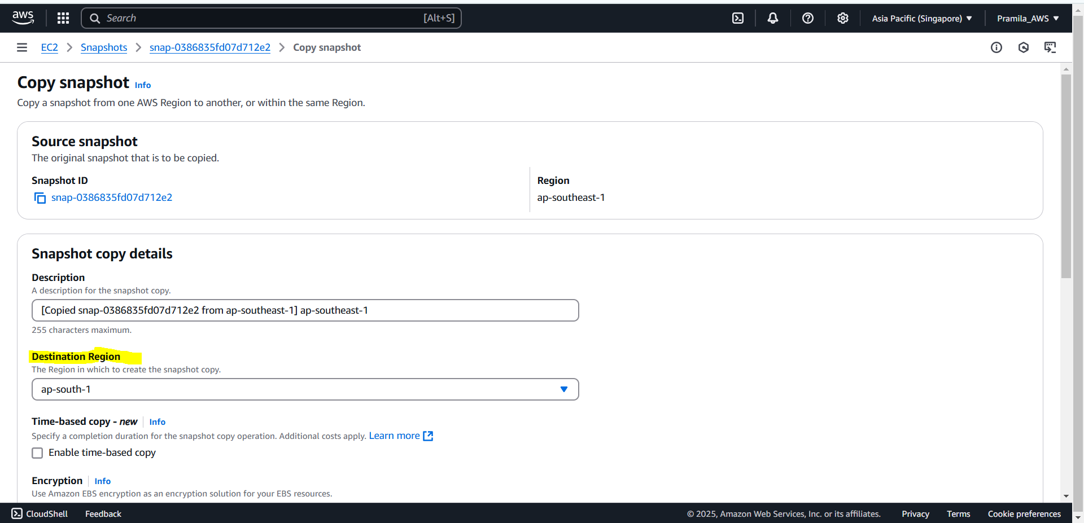

1. Now change the region to Mumbai and we are able to see snapshot in Mumbai region

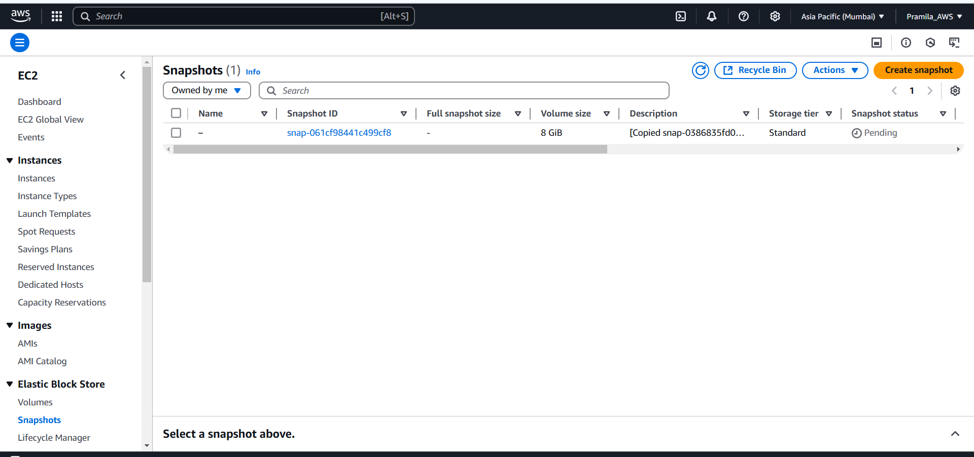

1. Now launch ec2 instance in Mumbai region

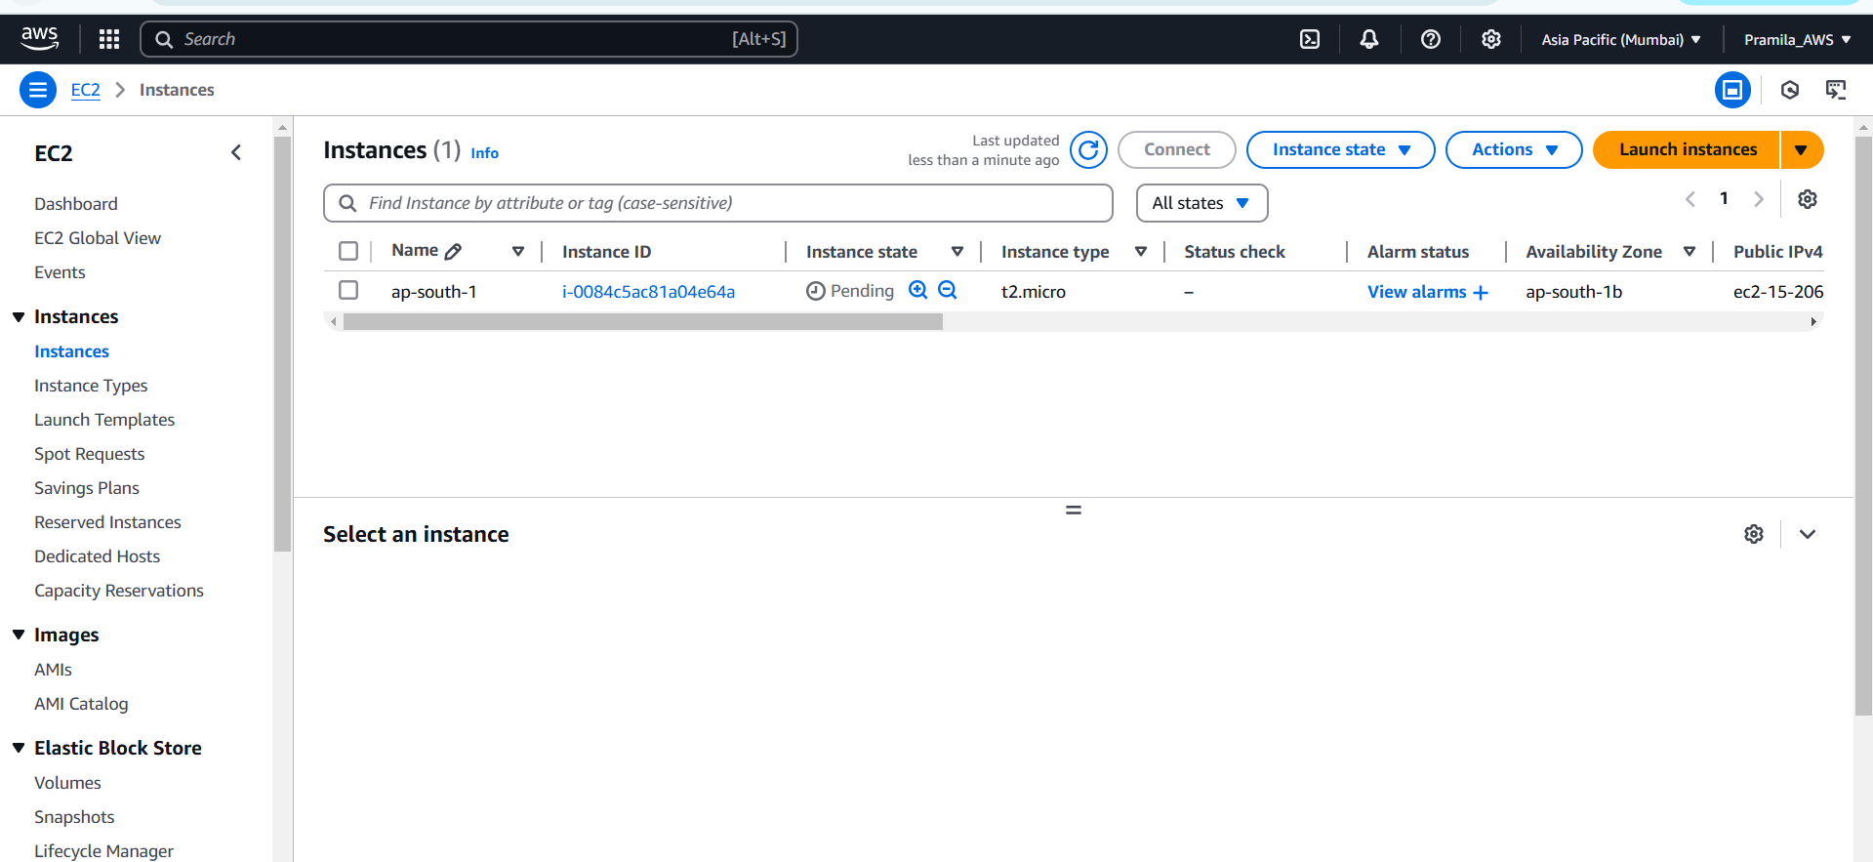

1. Now create volume from snapshot and create volume in same availability zone where ec2 instance volume get created

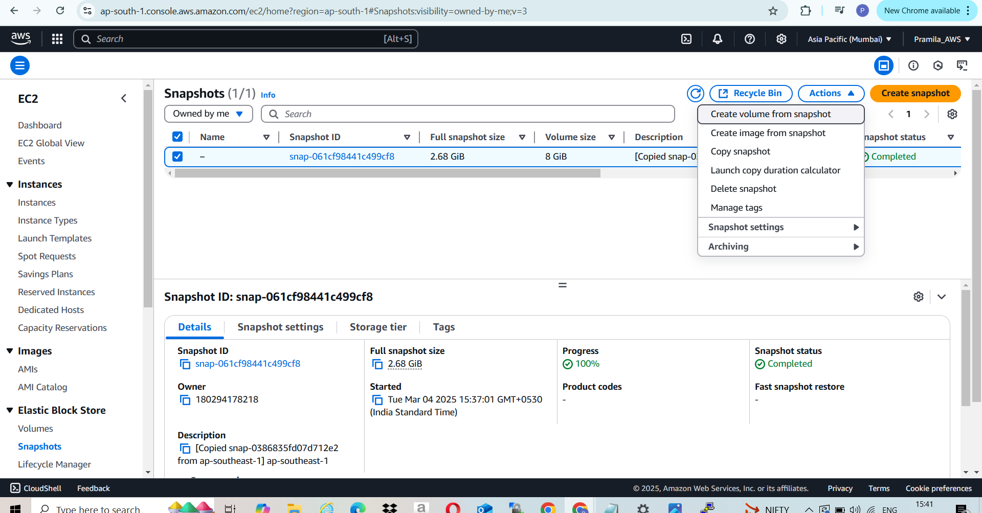

1. Created volume from snapshot

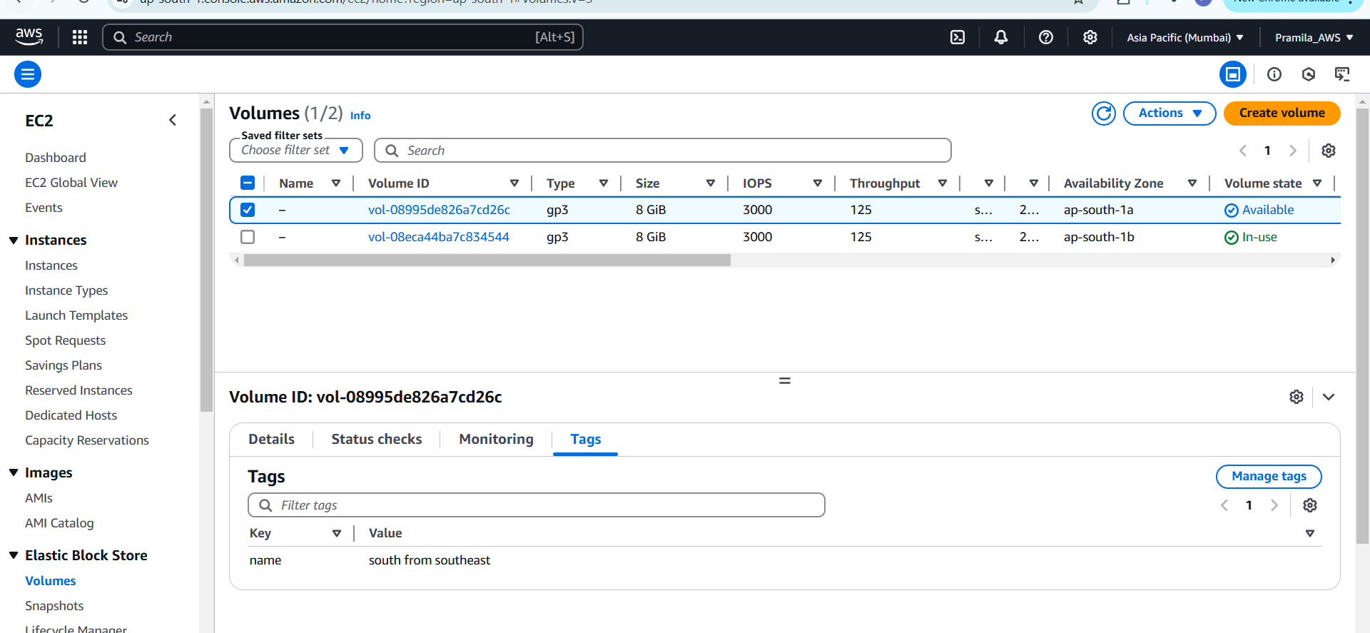

1. Now stop the ec2 instance for detach volume and attach new created volume

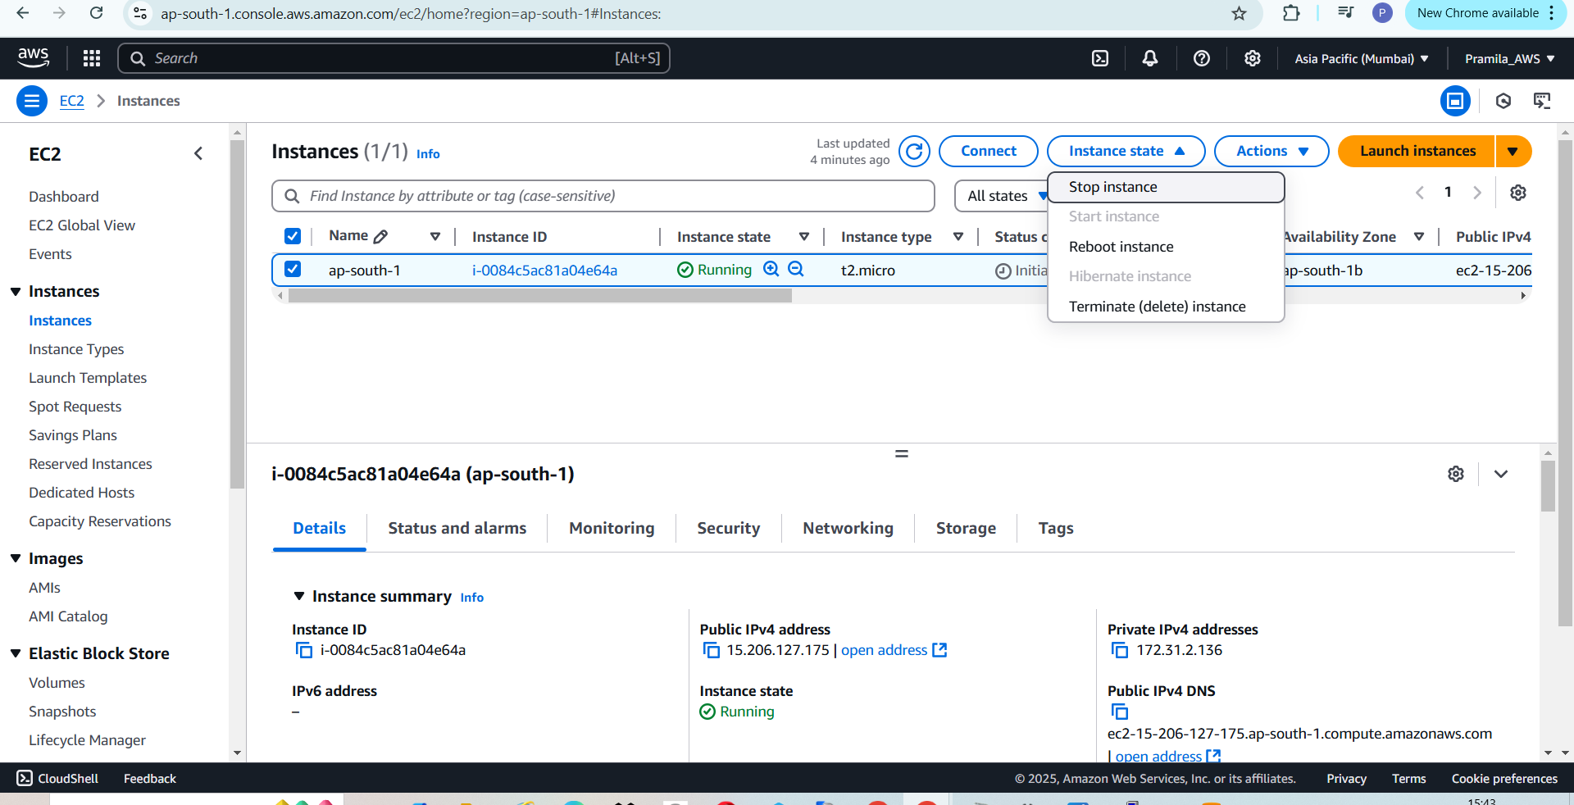

1. Detach volume from ec2 instance

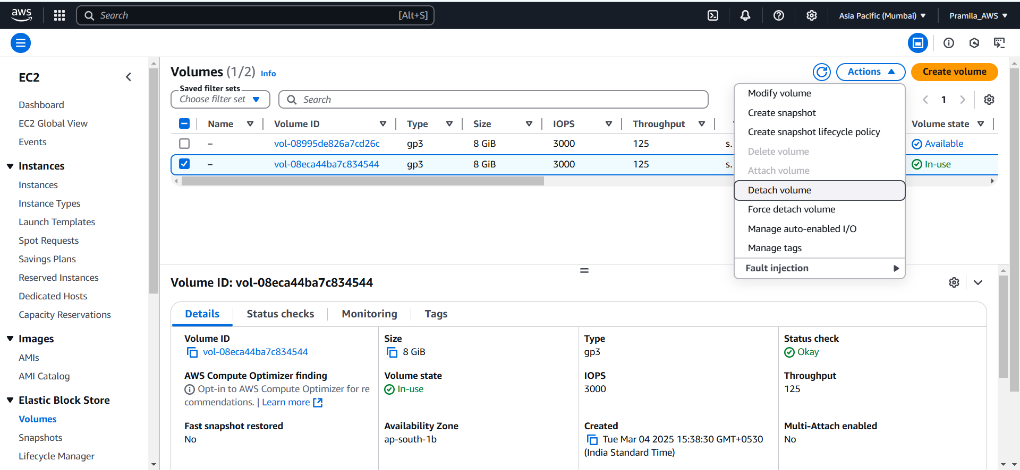

1. Now attach new created volume to ec2 instance

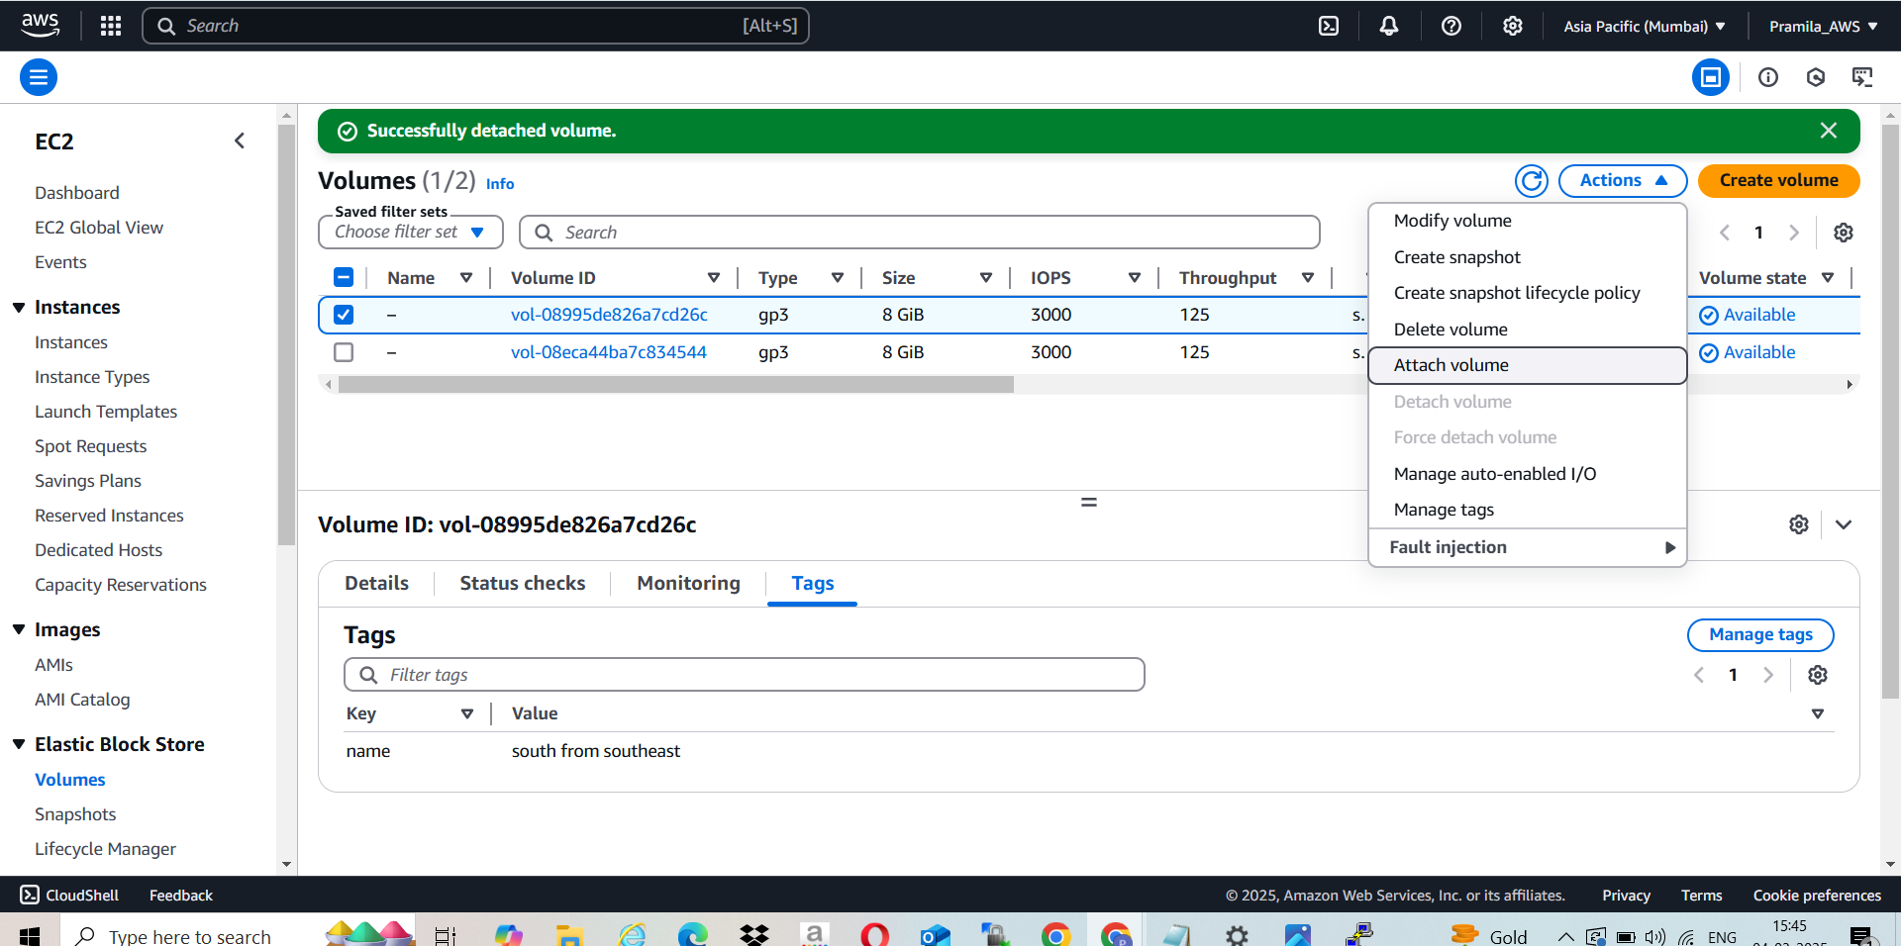

1. Add instance name while attaching volume to instance and device name as /dev/xvda i.e root ebs volume

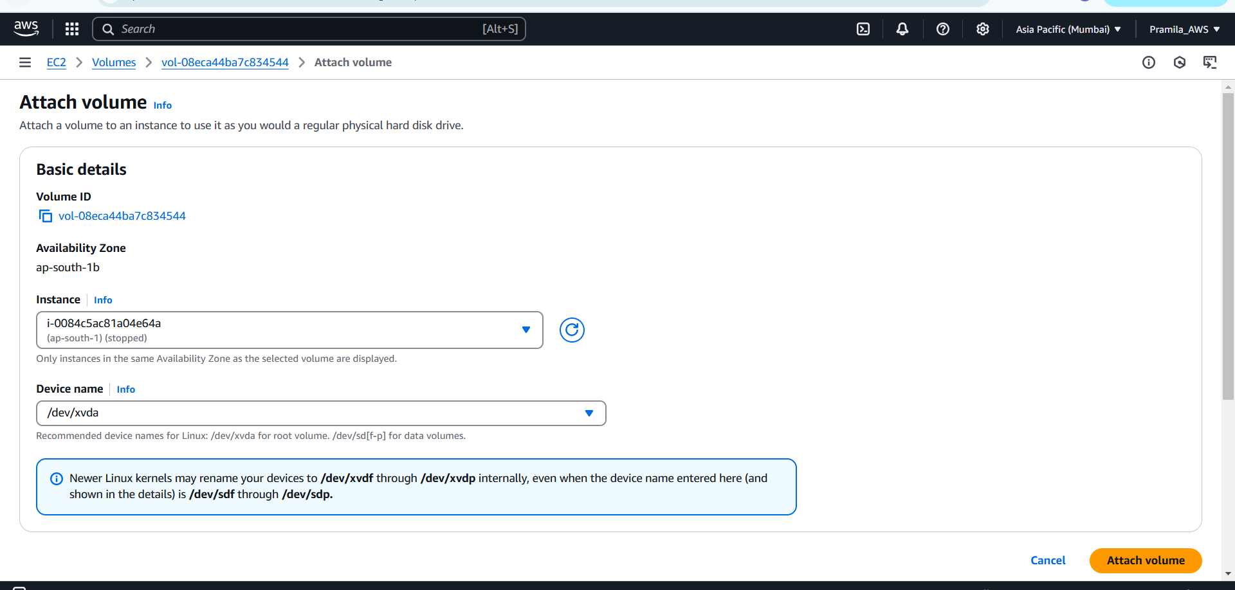

1. Now start the ec2 instance

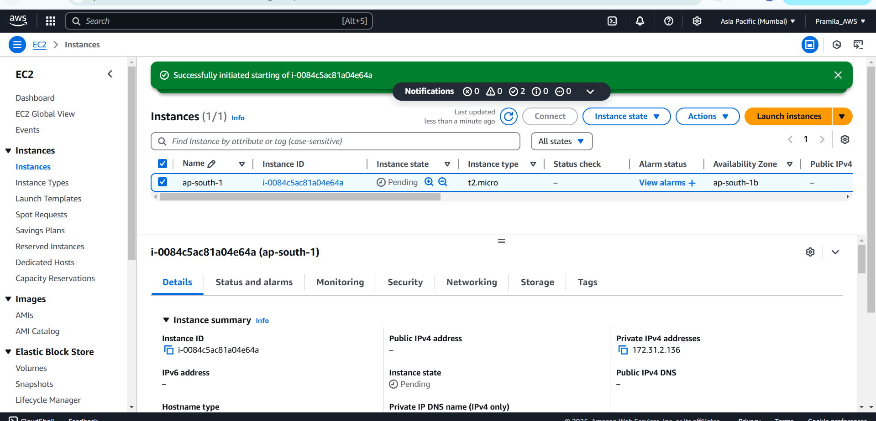

1. After starting ec2 instance we are able to see Jenkins is already configured

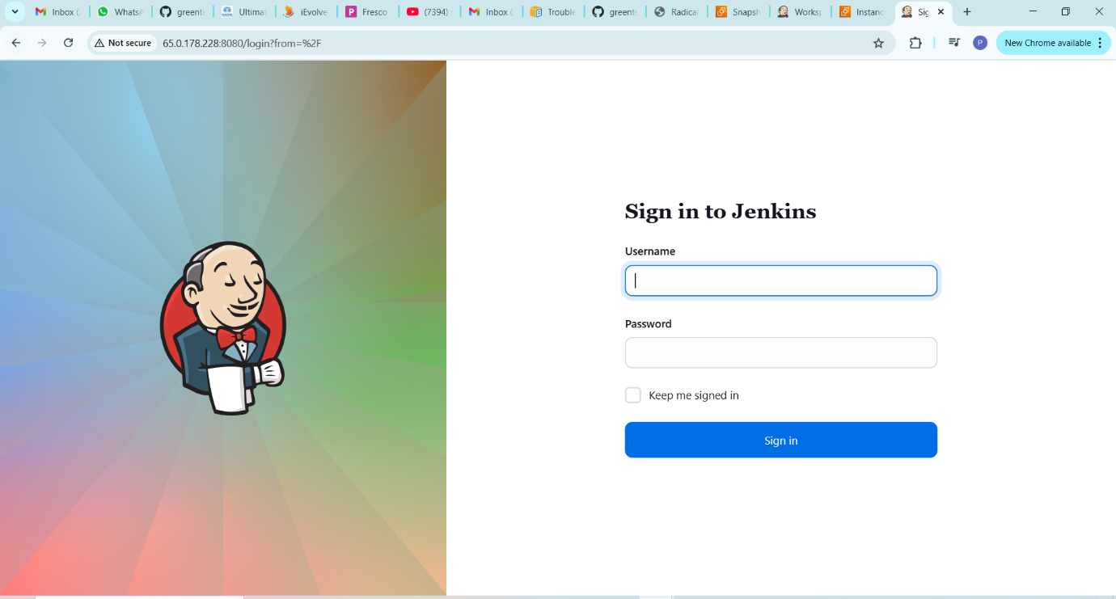

1. And also able to see demo which we have created in Singapore region Jenkins application

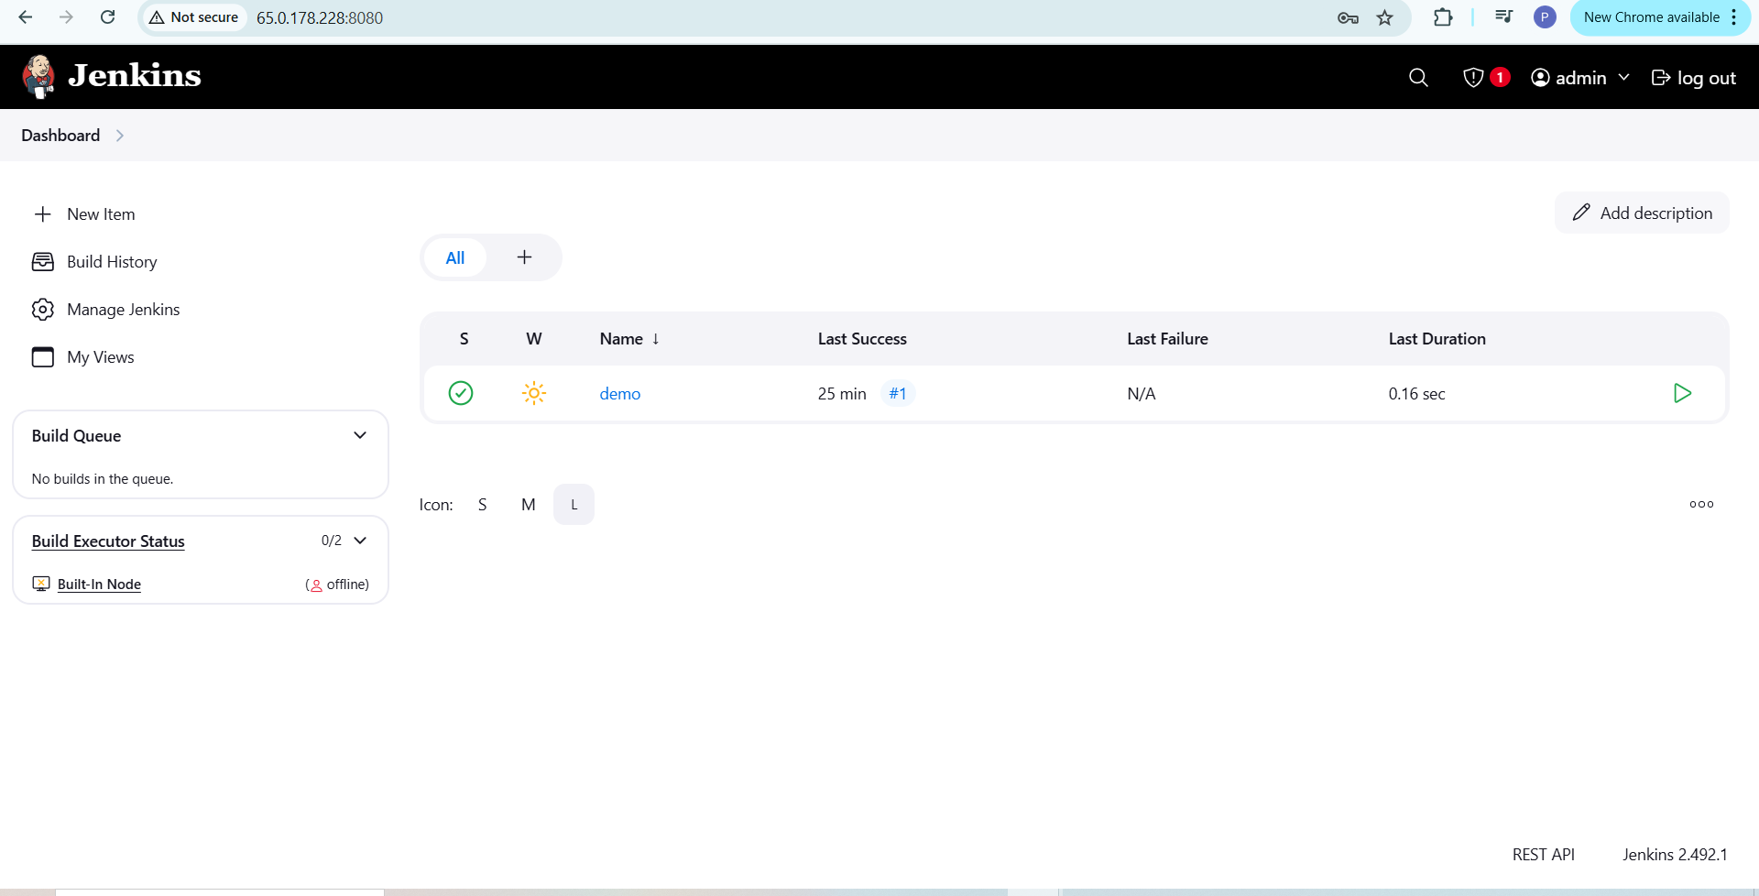

1. Able to create new item and build it

